**Logging:**

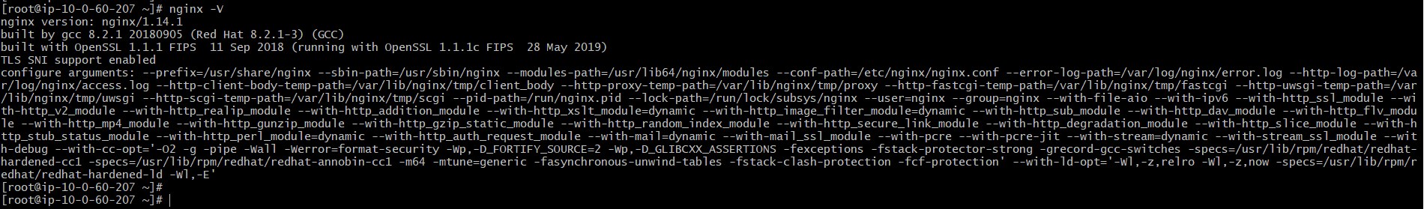

* By default, nginx comes with above configuration. It stores the error and access logs by default in **/var/log/nginx** folder.
* We can get the above information with **“nginx -V”** command.
* Access logs stores the information of client hitting the server. The log files be like as below.

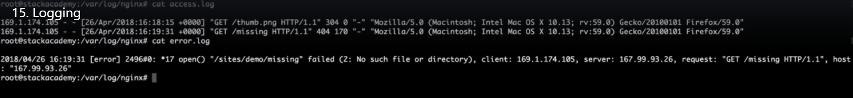

* We can also create custom logs or disable the logs for particular context.
* Let’s say we want to create a separate log for the all requests to **“/secure”.** Then we need to edit the config file as below.

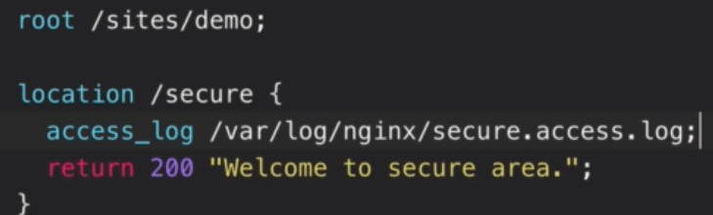

* We need to give the path of the logfile. Then save it and reload the configuration.
* When we immediately check the **“/var/log/nginx”** directory. We can see the new logfile created as below.

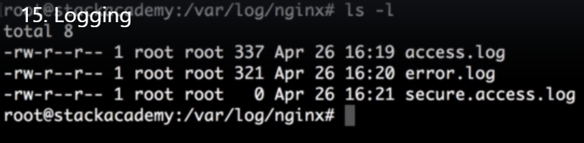

* And when we hit the URL with **“/secure”** context, we can see the new log file getting modified with the access logs.
* We can also use it for multiple logs as below.

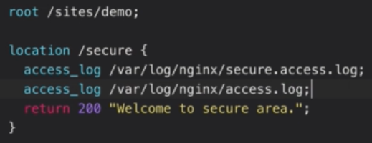

* We can also disable the logs for a particular context as below.

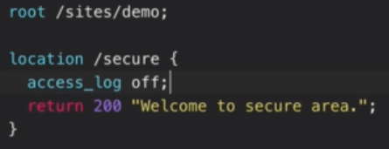

* We can use the same way configurations for error logs as well with **“error_log”** in config file.
* We can also set these configurations above the event context which is default.

**Setting up error log:**

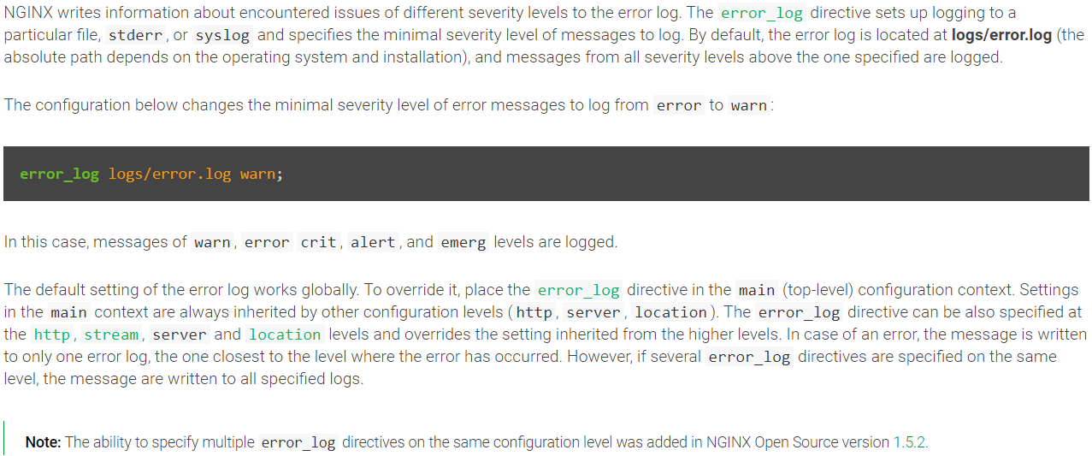

**Setting up the access log:**

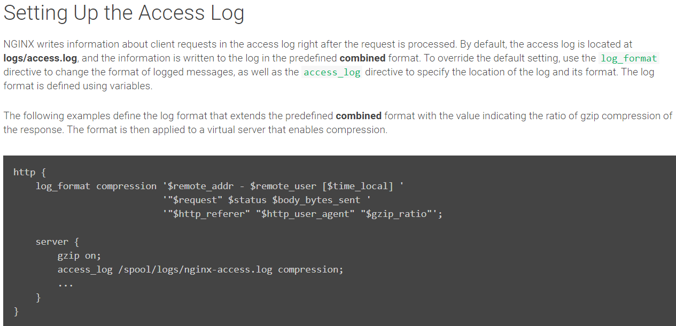

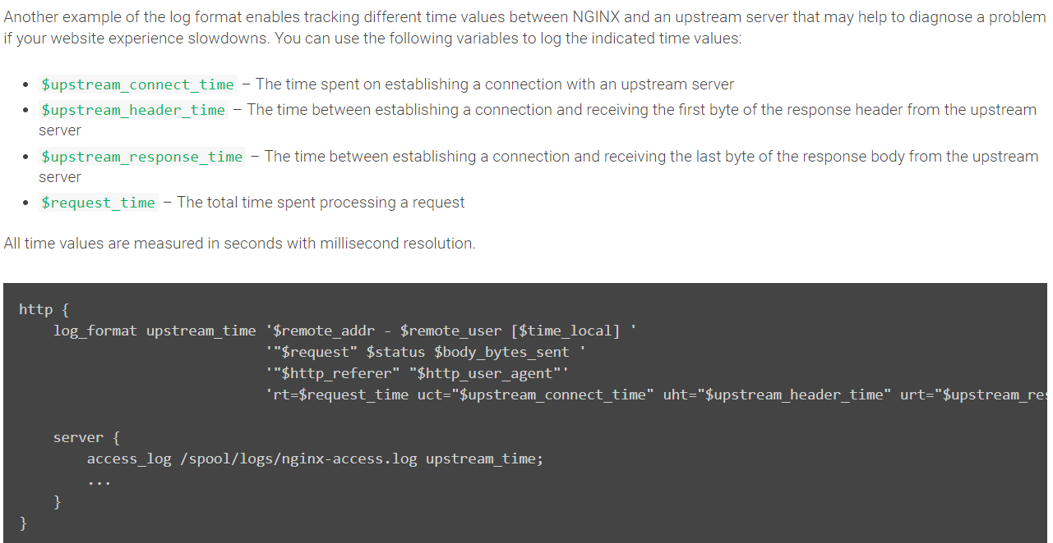

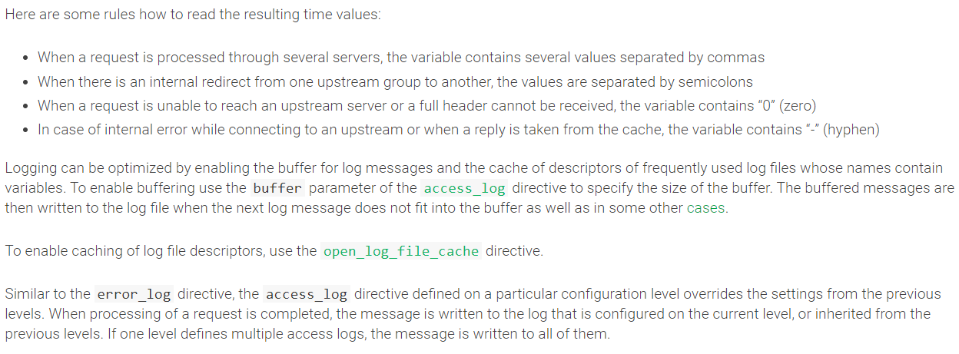

**Enabling conditional logging:**

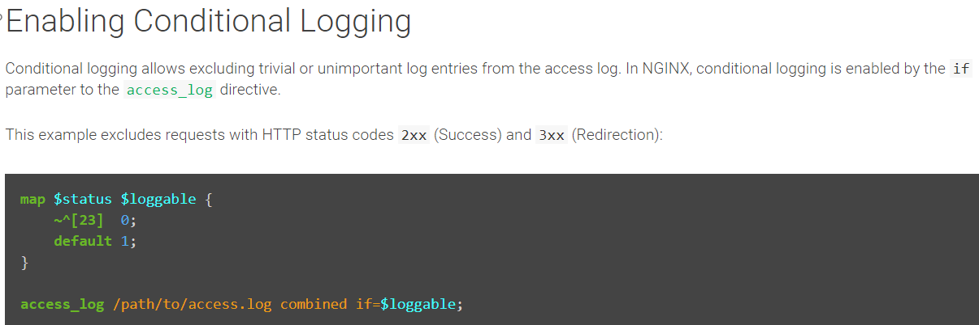

**Logging to syslog:**

